CONTENTS
INTRODUCTION 1
Chapter 1 A Brief History of Israel 2
Chapter 2 Jerusalem 10
Chapter 3 History of Jerusalem 15
Chapter 4 Jerusalem - Future 22
Chapter 5 Our Attitude toward Jerusalem 29

© Samuel Lamb
Add: | 15# Ronggui Lane,Ya He Tang,
 | North Dezheng Rd Guangzhou,
 | P. R. China
Post Code: | 510055
Tel: | 020-83821503
Oct. 2010 Update.

No Copyright
Scripture references:
Gen 14: 18, Psa 102: 21, 122: 3, 137: 5-6, Rev 21: 2,10.

INTRODUCTION
God chose Israel from among the countries of the world. Israel is situated in West Asia east of the Mediterranean Sea and is an important nation of the Middle East. God sent His Son, Jesus to be born in Israel. Jesus was therefore not a white European but belonged to the Asian yellow race.
Israel is the most important nation of the 200 or more countries of the world. She is the center and the focus of the world (Eze 38:12). Ancient maps were centered on Jerusalem. The most important city of Israel is Jerusalem, the capital, and the most important place of Jerusalem is the Temple. Christians ought to place special emphasis on Israel, praying for peace in Jerusalem. A Christian cannot be clear about his faith if he is not aware of the importance of Israel, Jerusalem, or the Temple. On the eve of Christ’s second coming, we would miss out on the wonders of the fulfillment of the Biblical prophecy if we do not take Israel and Jerusalem seriously! There are many prophecies in the Scripture. The prophecy concerning Israel was made clear by the rebuilding of this nation on May 14, 1948. We should observe the fulfillment of the prophecies from hundreds and thousands of years ago. But we need to pay special attention to the fulfillment of prophecies of this month and year. “…...and you will do well to pay attention to it, as to a light shining in a dark place, until the day dawns and the morning star rises in your hearts.” (2 Pet 1:19)
May God use this little booklet to help us know Israel and Jerusalem. As we look constantly at Jerusalem, we can confirm the truth of the Scripture, the reality of God’s existence, and the imminence of Christ’s second coming. Let us wakefully await the Lord’s return.

Chapter 1 A Brief History of Israel
To understand Jerusalem in detail, we must start with Israel. But we can only briefly talk about Israel now and then discuss about Jerusalem in more detail.

I. Period of Tribal Leaders - from Abraham to the leaders of the 12 tribes
The ancestor of Israel was Abram (later renamed Abraham). He was born in 2166 BC in Ur of Chaldea, i.e. Babylon or today’s Iraq (Gen 11: 31). He left home to enter Canaan in 2091 BC (Gen 12: 4). Canaan was named after the son of Ham (Gen 9: 18). Originally Canaan included Syria and Palestine (Gen 10: 19).
Abraham begot Isaac (Gen 21: 2-3), Isaac begot Jacob (Gen 25: 26) who was renamed Israel later by God (Gen 32: 28). Few countries are named after people. Rome was a person’s name and became the name of an empire. The nation of Israel was named after Jacob, the grandson of Abraham. Jacob had 12 sons who were ancestors of the 12 tribes of Israel (Gen 35: 22-26). The 12 tribes of Israel were developed based on the blessings of Jacob to his sons (Gen 49).

II. Period of Egypt
Jacob migrated to Egypt with his sons at the age of 130 years because of the famine in Canaan (Gen 47: 9). Earlier God had allowed Jacob’s son, Joseph to be sold to Egypt. Joseph later became the ruler of Egypt (Gen 45: 26). Jacob and his sons therefore escaped the famine. The Israelites lived in Egypt for a total of 430 years (Ex 12: 40), 400 years of which enslaved and mistreated (Gen 15: 13, Act 7: 6). Finally Moses led them out of Egypt in 1446 BC.

III. Period of Wandering in the Wilderness
The Israelites crossed the Red Sea to leave Egypt and arrived in the wilderness (Ex 14: 26-31). But God allowed them to wander in the wilderness for 40 years because they sinned (Num 14: 32-34). Later Joshua led them to enter Canaan (Jos 1: 1-4).

IV. Period of Judges
After the Israelites entered Canaan, they conquered Canaan under the leadership of Joshua to claim the land. Later, they were led by the judges for 300 years (Jdg 11:26). At that time, they had no kings, only judges. This period of 450 years from the time of Moses, through the conquest of Canaan to the time of Samuel is known as the period of judges (Act 13:20).

V. Period of Kings
This period lasted 430 years from the time the Israelites asked for a king to the time of their capture (1020-586 BC).

1. United Kingdom: 120 years in total
After the Israelites asked for a king, the entire nation was ruled initially by three consecutive kings. This is known as the period of united kingdom. The first king was Saul who set up his hometown Gibeah as the capital. He reigned for 40 years (Act 13:21). But he was not a good king. David was crowned after Saul’s death. He reigned for 40.5 years, first in Hebron for 7.5 years, then in Jerusalem for 33 years ( 2 Sam 5:5). Solomon, the son of David inherited the throne and reigned also for 40 years (1 King 11:42).

2. Divided Kingdom (930-586 BC)
After the death of Solomon, the kingdom was divided to the North Kingdom of Israel with Samaria as her capital and the South Kingdom of Judah with Jerusalem as her capital. The divided kingdoms were independently ruled by their own kings.
(1) The North Kingdom ( Israel ) : capital-Samaria, first king-Jeroboam ( 1 King 12:20 ), last king-Hoshea ( 2 King 17:1-6 ). In 722 BC, Samaria was conquered by Assyria and Israel became an Assyrian province west of the Jordan River ruled by an Assyrian governor. The entire Northern Kingdom fell and any Israelites were captured to Assyria ( 2 King 15:29; 17:6,23; 18:11 ). They never returned (1 Chr 5:26). The North Kingdom existed for 207 years (930-722 BC) with a total of 19 kings. None of these kings was good and 8 of them were killed or committed suicide.
(2) The South Kingdom (Judah): capital-Jerusalem, first king-Rehoboam, son of Solomon ( 1 King 14:21-31 ). The first 3 kings reigned during the struggle with Israel ( 1 King 14, 15) : 930-870 BC. There were 8 good kings: Asa ( 1 King 15:9-15 ), Jehoshaphat ( 1 King 22:41-50 ), Joash ( 2 King 12 ), Amaziah ( 2 King 14:1-20 ), Azariah ( 2 King 15:1-7 ) who was also called Uzziah ( 2 King 15:13 ), Jotham ( 2 King 15:32-38 ), Hezekiah ( 2 King 18 ), and Josiah ( 2 King 22 ). The last 2 kings were Jehoiachin ( 2 King 24:8-16, 2 Chr 36:9-10 ) and his uncle, Zedekiah who was crowned by the king of Babylon after the fall of Judah in 597 BC ( 2 King 24:17, 2 Chr 36:10 ). The South Kingdom of Judah ended in July, 586 BC with the fall of Jerusalem and the destruction of the Temple by Babylon. The South Kingdom lasted 344 years (930-586 BC), 137 years longer than the North Kingdom.

VI. Period of Exile and Return
This refers to Judah only, because Israel never returned after her deportation by Assyria. Judah was conquered by Babylon in 606 BC and became a province of the Babylonian Empire ( 2 King 25:22-30, 2 Chr 36:2-23, Jer 40:-44: ). Gedaliah was appointed governor and chose Mizpah as his capital ( 2 King 25:22-23 ).
In 538 BC, the Persians conquered Babylon and allowed the Jews to return to Judah in 536 BC. The Jews were in Babylon for 70 years ( 606-536=70 ) from the time of exile to their return ( 2 Chr 36:21 ). The Jews were then governed by the Persians for 205 years ( 538-333 BC ).
The return of the Jews were in 3 phases: the first group of 50,000 led by Zerubbabel in 536 BC in the first year of Cyrus king of Persia ( Ezra 1:-6: ), the second group led by Ezra in 456 BC ( Ezra 7:7 ), the third group led by Nehemiah in 445 BC.

VII. After the Return
This approaches the end of Old Testament. For 400 years after Nehemiah, there was no revelation from God. This is known as the Maccabean period. Judah was conquered first by Greece and then Rome until the birth of Jesus:

1. Hellenistic Period ( 333-142 BC )

2. Hasmonean Period ( 142-63 BC, Maccabean Revolt )

3. Roman Period ( 63 BC - 313 AD )
There were 1700 years from Abraham to Nehemiah.

VIII. The Diaspora
When the Roman general, Titus burned Jerusalem in 70 AD, approximately 1 million Jews were killed and the rest scattered all over the world in the following 65 years. Palestine was successively conquered by.

1. Byzantine Empire ( 330-636 AD ) following Constantine. Their buildings were dome-or cross-shaped.

2. Islam ( 636-1099 AD ).

3. Crusaders ( 1099-1291 AD ) who were temporarily subdued by Saladine from 1187 to 1193 but regained control from 1193 to 1291.

4. Marruck ( 1292-1516 ).

5. Ottoman ( Turkish ) Empire ( 1517-1917 ).

6. Britain ( 1918-1948 ), together with Jordan and the West Bank of Gaza.

IX. Rebuilding of Israel
By reason, there should be no possibility of the rebuilding of Israel. The people of India were not scattered all over the world. Rebuilding of India was comparatively easy. But the Biblical prophecy must be fulfilled ( Eze 3:24 ). The fall of Israel was a mystery, even more so the rebuilding of this nation. In the whole world, only Israel managed to maintain the same race, religion, culture, and language for 3300 years.

1. Zionism Movement: before rebuilding the nation of Israel, Jews must return to Palestine.
Theodore Herzel was an Austrian news reporter and publisher, also a Jewish leader. He started the Zionism movement in Switzerland in 1897 advocating the return of the Jews to Palestine to rebuild the nation of Israel. 1997 is the 100th anniversary of the Zionism movement.

2. Balfour Declaration
Initially, the British did not allow the Jews to return to Palestine. But because of the contributions of the Jews to Britain during World War I, British Prime Minister Arthur Balfour who was then the Secretary of Foreign Affairs signed the Balfour Declaration on November 2, 1917 allowing the Jews to resettle in Palestine under he government and protection of Britain.

3. Holocaust - Persecution of Jews by Hitler
Of the 9 million Jews in Germany, Hitler killed 6 million in a few days including 1.5 million children. In 1941, Germany invaded 14 European countries declaring her intention to annihilate the Jews. On June 22, Germany attacked USSR and killed another 1.5 million Jews.

4. Immigration of Jews
1918-1936 150,000 Jews returned
1936-1941 50,000 Jews per year entered the “city of refuge”
1946 despite the rejection of Britain, 113,000 Jews stole into Palestine. Britain set the border of Jordan east of the Jordan River.
2/1947 Failing to settle the dispute between Jews and Arabs, Britain allowed the intervention of United Nations.
14/5/ 1948 The Nation of Israel was formed with a population of 650-710,000 in Palestine.

5. The United Nations Mandate
The Palestinian Partition Plan no. 181 dividing Palestine into one Arab and one Jewish state was adopted by Israel on November 29, 1947, but was rejected by the Arabs. The UN originally planned to allow Israel to become an independent state on October 1, 1948. Of the 27,816 km² area in Palestine, Israel was given 15,200 km².

6. British withdrew from Palestine in May, 1948.

7. Israel declared independence at 14:01 on May 14, 1948 ( 16:01 Beijing time ).
Dr. Chain Weizman was appointed the first president and read aloud Isa 43: 5-10. Prime Minister David Ben Gurion read the “Declaration of Independence” and raised the Flag of the Star of David. The former USSR was the first nation to recognize Israel as a nation. President Truman of the USA also acknowledged Israel 11 minutes after her declaration, followed by other countries including Britain and France. On May 11, 1949, Israel became the 59th member of the UN. In 1992, PR China established diplomatic relationship with Israel.
According to Biblical prophecy, Israel will not be destroyed again. “Judah will be inhabited forever and Jerusalem through all generations.” ( Joel 3:20 ) “……I will plant Israel in their own land, never again to be uprooted from the land I have given them, says the Lord your God.” ( Amos 9:11-15, Jer 31:36 ) If Israel is destroyed again, then Biblical prophecy is untrue. But God is faithful. Whatever He promises will come to pass.

X. After Israel’s Rebuilding

1. Population Increase ( Eze 36:10, 38 )
There are 30 million Jews in the world, including 13 million of mixed blood. They live in over 100 countries, 30% in Israel, 50% in America, 15% in Europe.
1949 1,000,000
1952 1,300,000
1961 2,190,000
1967 2,340,000
1974 3,390,000
1984 4,000,000
1989 4,530,000
1991 5,000,000 ( 120,000 Christians )

2. Land Increase
(1) ancient times: 252 km long, 144 km wide, total area 36,316 km2, western border: Fertile Crescent, eastern border: Syrian-Arabic desert, southern border: Beer Sheba, northern border: Dan.
(2) time of rebuilding of Israel: 27,816 km2. God promised Israel the entire Palestine ( Canaan ), but Jews were scattered and ruled by several nations especially Arabs.
(3) After the rebuilding, Israel should reclaim the land. But the Arab countries accuse Israel of invading their land. Israel claims that the land is hers and says: “This is our land” whenever she conquers new land.
(4) Palestine: Palaistina ( Greek ); Pelescheth ( Hebrew ); land of Philistines.
The entire Palestine belongs to Israel. In the Bible, the terms Gaza; Philistia; Philistine; Palestina; Palestine refer to the descendants of Canaan ( Gen 10:6-14 ). The Aegeans moved to Palestine in 1200 BC ( Deu 2:23, Jer 47:4 ). They invaded Egypt in 1900 BC and were defeated. They settled in the coastal plain of the 5 cities, later called Palestine ( Gen 10:1,6,13-14, 1 Chr 1:11-12, Deu 2:23, Isa 14:29-31, Jer 47:4, Psa 108:9, Eze 25:15-17, Oba 19, Zep 2:5 ). The Philistines in western Canaan were the Palestinians of today. In Arabic, this country was called Philistine. There was never an Arabic country in Palestine.
(5) Some people may say: “When the Israelites entered Canaan, they conquered Canaan.” But the Canaanites were tribal people. All countries of the world originated as tribes, eg. Europeans conquered the tribes of North America and became USA, Canada, and Mexico. The return of Jews to Palestine after the diaspora to rebuild their nation is reasonable.
(6) Israel gradually recovered 81.6% of the land ( 21,501 km2 ) after the return through 5 wars. Therefore, 1.5-2.5 million Palestinians were chased out. These people accuse the Zionists of making them refugees. This is untrue because they actually invaded the land of Israel during the diaspora.

Chapter 2 Jerusalem
Jerusalem is a hill city of red colored stones surrounded by mountains with an altitude of 790 m. It is situated in the north of Judah 22 km from the Jordan River and the Dead Sea, and 45 km from the Mediterranean Sea. Jerusalem is the center of the world. Many important world events take place here. There are more battles here than any other city. It is the center of God’s plan: “ I will give one tribe to his son so that David my servant may always have a lamp before me in Jerusalem, the city where I chose to put my Name.” ( 1 King 11:36, 1 Chr 23:25, Psa 2:, Zec 12:1-3 ). This is also an Islamic center ( Isa 34:1-8, Ob, Psa 83:, Eze 25:, 35: ), but God will destroy them eventually.

I. Old City (East City)
This is very old, small, and scarcely populated. It is the historical Jerusalem, was destroyed until its rebuilding by the Turkish emperor Sulaiman 400 years ago.

1. Built on the hill
Mount Zion on the south, the temple mount in the northeast, also called Mt. Moriah because Solomon built the Temple here (2 Chr 3:). Abraham offered Isaac on this mountain (Gen 22:2). Now there are 2 mosques here ( the Dome of the Rock and the Mosque). The Jews cannot pray here. Golgotha is in the northwest. At the foot of the mountain were the garden and tombs of the rich. Later Jesus’ burial ground became a place for persecution of criminals. Mount of Olives is at the northern end of the eastern suburb. Surrounded by mountains are valleys in the east, west and south. The Kidron Valley is a beautiful spring between Jerusalem and Mount of Olives draining into the Dead Sea.

2. Holy land of three major religions with many sacred sites
Jerusalem is divided into 4 quarters: Jewish in the east-south, Christian (which contains the Temple of Garden Tomb) in the west-north, Arabic(Muslem) in the east-north, and Armenian quarter in the west-north. Jews constitute the majority and they started a new district in 1875 outside the city walls.

3.City walls
Before 1860, the city walls of Jerusalem were 40 m high with many gates. It took only one hour to walk around the walls.

4.Wailing wall ( western wall )
There is still a section of the city wall built by Nehemiah remaining near the golden gate. This is known as the wailing wall to the Jews, wet wall to the British, also called the western wall. After the Romans destroyed the Temple, they also completely destroyed the Temple mount and threw the large rocks of the Temple down the hill on the west side ( The west hill of the Temple was higher than the streets below ). After a long time, some Jews stacked the rocks together to form today’s wailing wall. The Jews have been wailing at the remains of the Temple here for many centuries. The men stand at the left ( north ) and the women at the right ( south ) parts of the wall. Because they grieve at the sight of the Old City wall, they cry when they sing Psalm 122: especially the last 4 words of the first verse. Some worship, read Scripture, and pray at the wall. Soldiers and youth are digging at the edge of the wall faithfully. They rejoice when they reach the foundation of the old Temple at 100 m.

5. The first deed of each returning Jew is to bend down to scoop up the soil and kiss it while his tears fall on the soil.

6. The poor lived in the lower side of the city, the rich and the royalty in the upper side.

II. New City (West City)

1. The new city was built in the 19th century and is a modern city.

2. Area: 176 km2, several times larger than the old city.

3. Population: >400,000, 75% of Jews living in the new city.

4. Wide roads: all of the city streets are named according to the 12 tribes of Israel. There are high buildings ( Eze 36:33 ).

5. Way of Holiness: From Joppa to Jerusalem is a highway, “And a highway will be there; it will be called the Way of Holiness. The unclean will not journey on it.…..” fulfilling the prophecy ( Isa 35:8 ).

6. Expansion of Jerusalem: “The days are coming”, declares the Lord, “when this city will be rebuilt for me from the Tower of Hananel to the Corner Gate. The measuring line will stretch from their straight to the hill of Gareb and then turn to Goah. The whole valley where dead bodies and ashes are thrown, and all the terraces out to the Kidron Valley on the east as far as the corner of the Horse Gate, will be holy to the Lord. The city will never again be uprooted or demolished.” (Jer 31: 38-40, Zec 14:10) This prophecy is being fulfilled as they are marking out the zone of expansion.

Four Zones of East Jerusalem
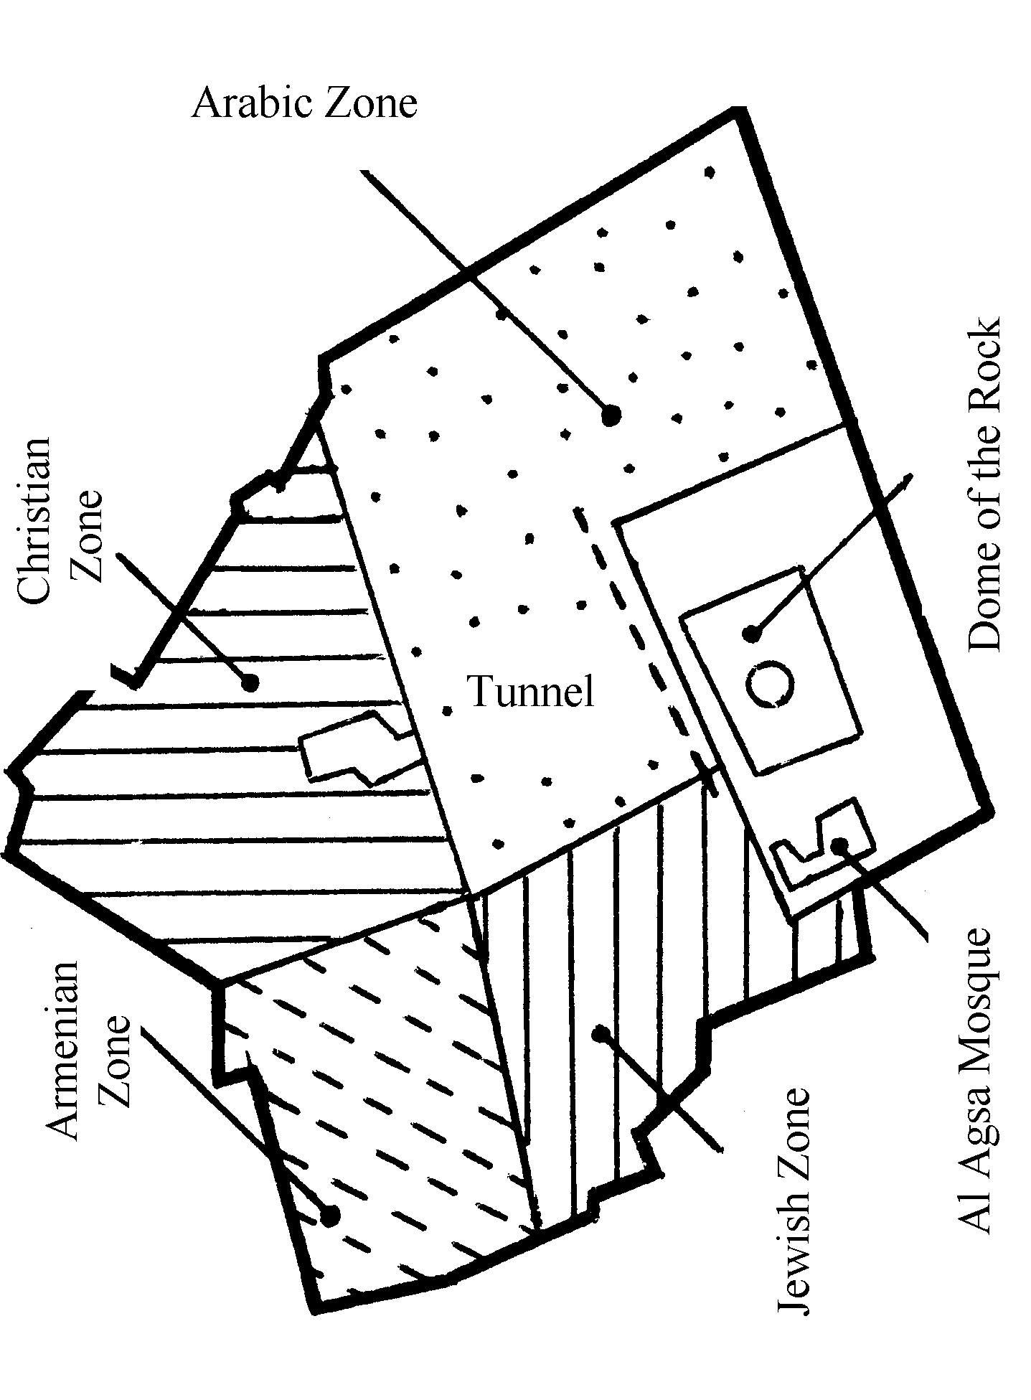
East Jerusalem (The Old City)

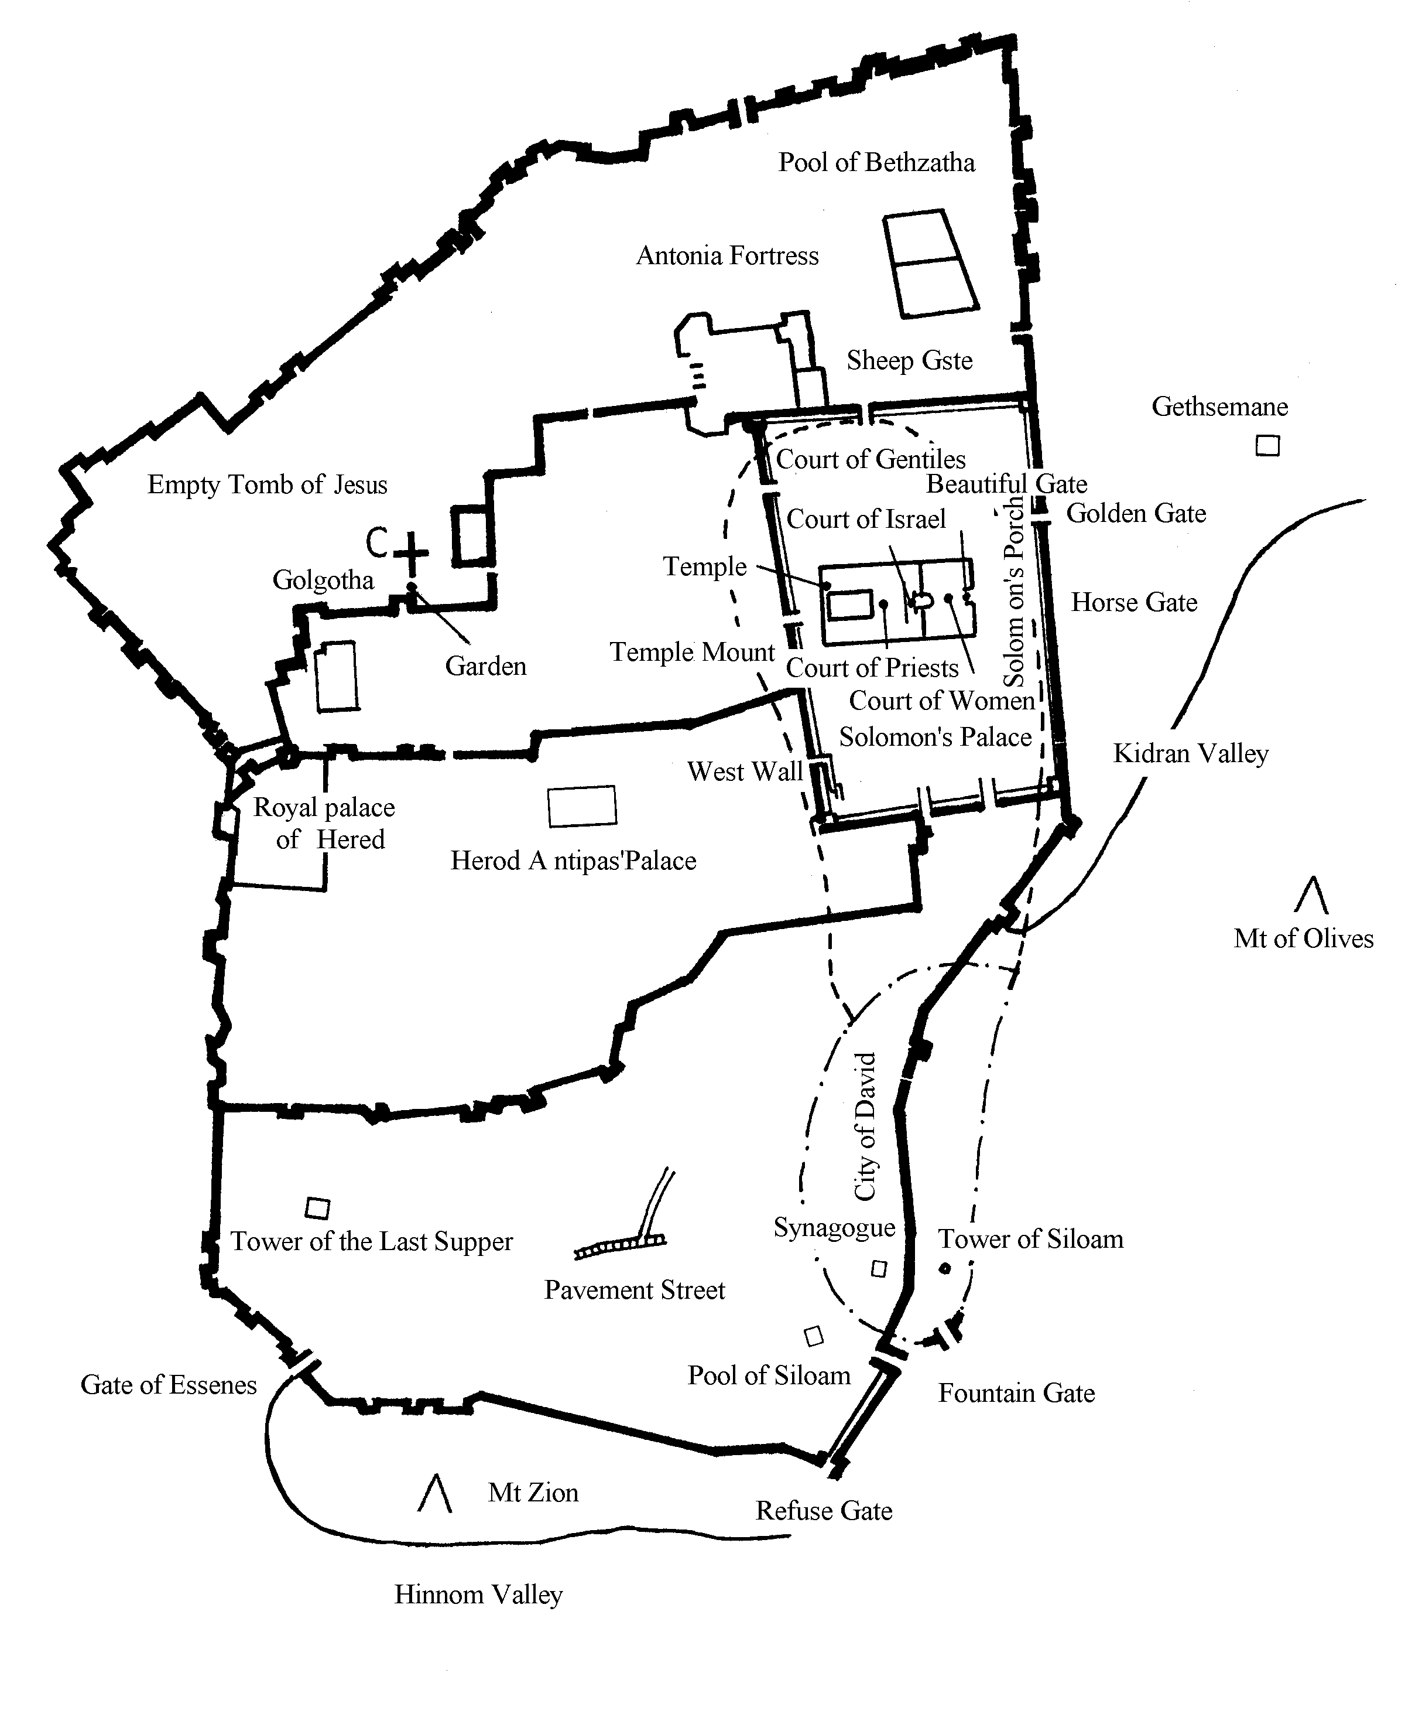

Chapter 3 History of Jerusalem
We talked about the history of Israel briefly. When we discuss about the brief history of Israel, we cannot avoid the problems of Jerusalem. We will now discuss in detail the history of Jerusalem. How did it come about? Is Jerusalem the capital of Israel or the Arabs? What is the future of Jerusalem, etc?

I. Melchizedek King of Salem
“Then Melchizedek king of Salem brought out bread and wine. He was priest of God Most High, and he blessed Abram, saying, …” (Gen 14:18-20) Melchizedek was a king of righteousness, the first designer and builder. King Melchizedek of Jebusite had a gentle temper, he therefore called this city “Urusalem”, meaning “City of Peace”. “Jaru” means city; “Jarusha” means property; “Salem” means complete peace. Jerusalem is therefore “a city of complete peace”. Unfortunately, Jerusalem was a battlefield historically but will eventually be a city of eternal peace. Arabs called it “Cutish?” meaning holiness. Melchizedek king of Salem met Abram (Abraham) on Mount Moriah. He is a type of Christ (Heb 7:1,3,15-16,24-26).

II. Name

1. Jebusite city is Jerusalem (Jos 15:8, 18:28, Jdg 19:10). This was a city of the Amorites. In 3000 BC, the Jebusite tribe of Canaanite immigrated from the Arab Peninsula. King of Jerusalem was Adoni-Zedek (Jos 10:1).

2. “Fortress of Zion”: Jerusalem was also called the fortress of Zion (2 Sam 5:7). Mount Zion is at the south of Jerusalem. Jerusalem was originally built on Mount Zion. Because of the gradual expansion of the city, Mount Zion became one of the several city hills.

3. “City of David”: Jerusalem was also called the city of David (1 King 2:10, 3:1, 8:1, Neh 3:15) because it was built by David, also known as “the city where David settled” ( Isa 29:1 ).
Archaeologists unearthed the clay tablet of Talmud proving the early existence of this city.

III. First Conquest by Judah
“The men of Judah attacked Jerusalem also and took it.…..” ( Jdg 1:8 ) but they took only a portion of Jerusalem ( Jdg 1:21 ).

IV. David Made Jerusalem the Capital
David was king of Hebron for 7 1/2 years and king of Jerusalem for 33 years. He was the first to make Jerusalem his capital in 1004 BC ( 2 Sam 5:5-10 ). The year 1996 was the 3000th anniversary of the capital of Jerusalem ( 1004 + 1996 = 3000 ). Israel began to celebrate in September, 1995 ( September is the Jewish new year ). They celebrated for 15 months (until November 1996 ) spending 8 million US dollars. This was the capital of Israel.

V. Building of the Temple
Israelites worshipped in the tabernacle in the wilderness. After they entered Canaan, they wanted to build a Temple in Jerusalem. God did not allow David to build the Temple because he was a warrior. God wanted him to prepare the building material for his son Solomon to build. In the 4th year of the reign of Solomon, the construction of the Temple began ( 1 King 6:1 ). It took 7 years to complete in 996 BC ( 1 King 6:1,38 ). Queen of Sheba was overwhelmed when she came to visit ( 1 King 10:1-5 ). Later, “The weight of the gold that Solomon received yearly was 666 talents.” ( 1 King 10:14 ) Note: 666 is a bad number ( Rev 13:18 ). This became the root of calamity later on.

VI. Invasion before the Captivity
Before the capture of Israel, Jerusalem was often invaded: by Shishak in 970 BC; by Philistine and Arab in 884 BC; by Pharaoh Necho in 610 BC.

VII. Captivity by Babylon
Babylon conquered Jerusalem for 70 years from 606 to 536 BC. Jerusalem was destroyed, the Temple treasures removed to Babylon, and the Temple burned ( 2 Chr 36:17-21 ).

VIII. Return
After Persia conquered Babylon, Persian king Cyrus allowed the Jews to rebuild the Temple in 538 BC.
1. Rebuilding the Temple ( Ezra 3-6 )
In the second month of the second year, they built the foundation ( Ezra 3:8 ) and had to stop for 16 years because of the Samaritan opposition in the 2nd year of the reign of king Darius ( Ezra 4:24 ). Four years later ( March, 515 BC , Ezra 6:15 ), the Temple was completed and dedicated ( Ezra 6:16 ). This was the second Temple, commonly known as the Temple of Zerubabbel. It was very small.
2. Rebuilding the city wall
In 445 BC, one century after the first return, they still had not rebuilt the city wall. Rebuilding was started after the arrival of Nehemiah ( Neh 2:11 - 6:19 ) It took 52 days to complete ( Neh 6:15 ). ( Some say that it took 2 years and 4 months ). Upon completion, Nehemiah was appointed governor of Jerusalem.

IX. Before the Birth of Christ
332 BC Alexander the Great visited Jerusalem.
320 BC Ptolemy Sater invaded Jerusalem.
302 BC Jerusalem was given to Egypt.
170 BC Antiochus Epiphiny destroyed the wall.
63 BC Pompey conquered Jerusalem. Antipater, father of Herod the Great rebuilt the city wall.
19 BC Herod proposed to build another majestic Temple without tearing down the small one. In actuality, the small Temple was demolished. Herod had 1000 priests trained as builders. The work was continuing at the time of Jesus and after the death of Herod. “The Jews replied: ‘ It has taken forty-six years to build this temple……” ( John 2:20 )

X. Fall of Jerusalem
The sky turned dark after Jesus was nailed on the cross.
66 AD Jews rebelled against Rome.
69 AD General Titus laid siege to Jerusalem, tore down the city wall, threw torches and stones at the city. There was shortage of food in the city.
8/8/70 AD Jerusalem fell and the Israelites were scattered throughout the world ( Deu 29:24-28).

XI. 70 AD - Rebuilding of Isreal

1. Roman Occupation (61-330 AD): In 313 AD, Constantine built a cathedral at the Garden Tomb, which was also called “Hall of Resurrection”, located at Tolorosa Blud Street, in the west-north of the Old City. For several times it had been rebuilt, it was destroyed again each time.
To prevent the fulfillment of prophecy, Julian Caesar planned to rebuild the Jerusalem Temple in 362 AD so that Jerusalem would be ruled by Jews and not desecrated by Gentiles. He decided to build the Temple at the peak of Mt Moriah and sought the support of enthusiastic Jews. Before the rebuilding, he boasted of preventing the fulfillment of Jesus’s prophecy. However, when the governor helped to proceed, a fire ball spurted suddenly and continuously from the bricks near the foundation of the Temple so that the work could not be started.

2. Byzantine Occupation (330-636): occupied by Persia in 614.

3. Arabic Occupation (632-750): occupied by Saracens.

4. Jerusalem became the holy land of Islam until 666. Because Mohammed, the founder of Islam had flied to the seventh sky, seeing prophets and heavens. In that time, 636-1098, Islam built up the Dome of the Rock. Jerusalem was occupied by Islamic army from 636 to 1098 and by Turkey in 1076.

5. Egyptian rule (1098 AD).

6. Latin Occupation (1099-1189): first by the Crusaders (1099-1187), then by Saladin (187-1193).

7. Mongolian Occupation (1240-1250): by Carizmians in 1243.

8. Arabic Occupation (1270-1517): Egyptian Mamalukes.

9. Ottoman Occupation (1517-1917): by Egypt in 1832, again by Turkey in 1841 ( Eze 16: ).

10. British rule ( 1918-1948 ).

11. 11/29/1947 United Nations decided to govern Jerusalem as an international city. This was objected by Arabic countries, thus the UN divided Jerusalem into east and west zones.

12. The wailing wall and Jewish quarter: Israelites purchased these from the Arabs and built a hospital and Hebrew University. This area was occupied by Abdullah, king of Jordan. American President Carter considered Jerusalem an occupied zone.

XII. Formation of the Nation of Israel
The UN assigned the Old City to Arabs and the New City to Israel.

XIII. After the formation of Israel

1. Tel Aviv was a temporary capital. This was a new city in north Joppa along the Mediterranean coast. It was the only residential area for Jews, was built in 1909 with an entirely Jewish population, was combined with Jaffa in 1950. It has a complete administrative system, was a deep water port, and had a population of 320,000.

2. 1/23/1950 Israel declared Jerusalem as the new capital and was threatened by the Arabic countries.

3. 6/5/1967 In the third Middle East War, Israel reclaimed the old city of Jerusalem at 10:15 pm on June 7, destroyed the dividing wall to unite the east and west zones. On July 1, the Feast of Trumpet, the Israelites had a victory parade. This was the first free day of Israel in 19 years. 200,000 people prayed at the wailing wall and declared to the world that Jerusalem was the holy land, their inheritance. At the same time, the area along the River Jordan became an Israel province.

4. 10/6/1973 At the 4th Middle East war, Jerusalem was in danger. Eventually, Israel won.

5. 1978 Saddah requested Israel withdrawal from the east zone but was refused by Begin. If the Arabic countries accepted the UN proposal of making Jerusalem an international city, Israel would not be able to reclaim it. The objection of Arabs ironically accomplished God’s will (Zec 2:12-13).

6. 7/29/1980 UN passed a resolution to force Israel to withdraw from Jerusalem before 11/15. This was refused by Israel. 7/30 Israel National Assembly passed the constitution and declared Jerusalem as Israel “a never divided capital”. At this critical time (9/22/1980), Iraq—Iran war broke out and the Arab countries were divided.Thus God saved Israel.

7. 11/1/1994 Jordan supported the Palestinians to make east Jerusalem the Palestinian capital. Hussein, king of Jordan proposed to transfer the Islamic holy land of east Jerusalem to Palestine. 10/26/1994, Jordan and Israel signed a peace treaty. Israel recognized the special status of Jordan in governing Jerusalem’s Islamic holy land. This was not satisfactory to the Palestinians.

8. 9/4/1995 ( Israel New Year ) Israel started to celebrate the 3000th anniversary (1996), of Jerusalem as the capital.

Chapter 4 Jerusalem - Future
We have already discussed about Jerusalem’s past and present and know that God gave it to Israel as the capital city. Now Palestine wants to fight with Israel to make Jerusalem the Palestinian capital. Let us not get anxious but look at God’s promise and Israel’s future. Then we will see that God is sovereign over all.

I. The Territory God Promised for Israel
In the Bible, God promised to make Abraham a nation: “……To your descendants I give this land, from the river of Egypt to the great river, the Euphrates.” ( Gen 15:18-20 ) Jehovah also said to Moses: “ I will establish your borders from the Red Sea to the Sea of the Philistines, and from the desert to the River.” ( Ex 23:31) God also told Joshua: “Your territory will extend from the desert to Lebanon, and from the great river, the Euphrates—all the Hittite country—to the Great Sea on the west.” ( Jos 1:4) God said to Micah: “ In that day people will come to you from Assyria and the cities of Egypt, even from Egypt to the Euphrates and from sea to sea and from mountain to mountain.” ( Mic 7:12)
From the above prophecies, we find out Israel’s final territory ( including Jerusalem ) :
southern border: river of Egypt
eastern border: River Euphrates
northern border: Assyria, Lebanon
western border: Mediterranean Sea
However, we know from history that even at the height of her strength, Israel never conquered all that territory. Since God had promised, it will come true. Israel had proposed “Great Israel Plan”. The former Minister of Defence brought up “ Israel war plan in the 80’s” in order to achieve the Great Israel Plan east to Iran, Afghanistan, and Pakistan; north to Turkey; west to Mediterranean Sea; south to Africa combined with South Africa.

II. Blocked by Satan
Satan has always tried to prevent Israel from reclaiming the land and making Jerusalem her capital.

1. Yitshak Rabin: He was the first Israel-born Premier. “Rabin” is close to ”rabbi” and means head of many. The antichrist in Dan 9:27 will make a covenant with many. The antichrist is the last one to make peace treaty, but Rabin was the first head or the first of many. He exchanged land for peace. It is not biblical to make treaty with the Gentiles and their gods: “Do not make a covenant with them or with their gods. Do not let them live in your land…” ( Ex 23:32-33, Isa 14:31-32) But the Bible did prophesy that the Israelites would make covenant with them. They make a covenant with the Arabs to gain peace in the Middle East, then the seven years of tribulation will start. However, it is not in God’s will to exchange land for peace. Hence Rabin was murdered shortly on 11/4/1995. This “head” fell from his body. “When the sun had set and darkness had fallen, a smoking firepot with a blazing torch appeared and passed between the pieces.” ( Gen 15:17) According to the Hebrew alphabet, this becomes “fire, fire, bad Rabin.” Rabin was broken into pieces like the sacrifice. He did not glorify God.

2. Shimon Peres succeeded Rabin: Shimon means flying eagle, faster. On 11/12/1995, the day of his ordination as Premier, there was an earthquake of 6.2 Richter scale. God warned him to not give away land ( Lev 25:23). But he even wanted to give away Bethlehem and Jerusalem to Palestine. Thus he was dismissed shortly. Flying eagle flies rapidly: he gave away land even faster, so he fell from power rapidly.

3. Benjamin Netanyahu: Benjamin means “the son of right hand”. Netanyahu means “united”. He became Premier at the age of 46 years on 5/29/1996. He is an important figure in the Likud Party of Israel. He insisted on the “Great Israel Plan” and objected to divide Jerusalem. He gave a speech in the White House on 7/10 and declared the whole Jerusalem as a permanent capital of Israel. He refused to recognize Palestine as a nation and objected to yield the Golan Heights to Syria. After he was elected, he immediately went to the wailing wall to pray. He supported peace in the Middle East but not by selling land. At present, he faces opposition from many countries especially the Arab countries. But then, the relationship between USA and Iraq became strained! This is God’s plan. Up to 9/15/1996, he still insists “I shall insist on my basic policy ”, “Things like Jerusalem are holy”. May God give him strength to act according to the Bible.

III. After Christ’s Second Coming
Christ’s second coming can be divided into two stages: to the air and to the earth. When He comes to the air, the earth will enter into seven years of tribulation. After the tribulation, He will come to the earth. Now let us look at the situation in Jerusalem at the Second Coming.

1. When Christ comes to the air, the earth will enter into seven years of tribulation. There will be a Temple ( third Temple ) in Jerusalem: “……there my house will be rebuilt. And the measuring line will be stretched out over Jerusalem, declares the Lord Almighty.” ( Zec 1:14-17, 2 Thess 2:4, Rev 11:1-2 ) There is no Temple yet and the Muslim Al Agsa Mosque is standing on the Temple Mount. The Temple was close to the east gate which is now opposite the Dome of the Rock. To build the Temple, Israel must tear down the mosque. But the latest discovery is that the holy of the holiest was actually situated 100 m north of the Dome. That being the case, the mosque needs not be disturbed to build the Temple. The construction material has been prepared. It only takes two or three months to build.

2. During the seven years of tribulation, except for us and a few Jewish Christians who will be raptured, most Jews will suffer ( Rev 7:4-8 ). After their repentance, they will be sent to preach the gospel. They will have freedom of belief and can worship in the Temple ( Rev 11:1 ). During the second half of the Great Tribulation ( 3 1/2 years), Antichrist will revoke the covenant and they will lose the freedom of belief. “…… In the middle of the seven he will put an end to sacrifice and offering.” ( Dan 9:27) Then the Temple, especially the outer court will be trampled by Gentiles for 42 months: “But exclude the outer court; do not measure it, because it has been given to the Gentiles. They will trample on the holy city for 42 months.” (Rev 11:2) Being persecuted by Antichrist, they will escape to the east of the River Jordan ( Rev 12:13-14 ). Finally God will open the fountain to cleanse them from sin and impurity ( Zec 13:1 ).

3. Christ descended to save the Israelites: “On that day his feet will stand on the Mount of Olives, east of Jerusalem, and the Mount of Olives will split into two from east to west, forming a great valley, with half of the mountain moving north and half moving south.” Christ will not descend on USA or Korea but on Mount of Olives, east of Jerusalem. Then the mountain will split. Thank God, someone discovered recently that Mount of Olives is already starting to split. When He descends on Mount of Olives, He will enter Jerusalem through the garden of Gethsemane and the east gate. The third Temple is close to the east gate which is now sealed so that no one may enter. But many believe that when Christ returns, the east gate will open automatically.

4. In the Millennial Kingdom, Jerusalem will not only be the capital of Israel but also the capital of the world ( Zech 14:8-11). Israel will be a kingdom of priests and the whole world will be blessed through Jerusalem( Ex 19:1-6). Nations will worship Jehovah and celebrate the Feast of Tabernacle in Jerusalem every year ( Zec 14:16-21). Nations will learn from Jerusalem: “Many nations will come and say, ‘Come, let us go up to the mountain of the Lord, to the house of the God of Jacob. He will teach us his ways, so that we may walk in his paths.’ The law will go out from Zion, the word of the Lord from Jerusalem.” ( Mic 4:2, Isa 2:1-2) They will belong to the tribes of Israel ( Eze 47:21-23). In the kingdom of heaven, Israel will be the head of all nations ( Eze 39:25-29, 48:1-29). Jerusalem will exist forever: “Judah will be inhabited forever and Jerusalem through all generations……The Lord dwells in Zion.” ( Jol 3:20-21)

5. New Jerusalem-New Heaven: After the Millennium, Satan will be thrown into the lake of fire( Rev 20:10), Lord Jesus will judge all the dead non-believers on the great white throne( Rev 20:11-15). Afterward, we will enter the new heaven and new earth of eternity. New earth is the renewed earth; new heaven the best new Jerusalem in the heavenly home, alias Holy City, coming down out of heaven( Rev 21-22:5). Some people interpret Rev 21:2 to mean that Jerusalem is Christ’s bride. Actually, this verse does not refer to”the bride” but “prepared as a bride beautifully dressed for her husband”. Please note that new Jerusalem is a city not a person. But this city is so beautiful “as” a bride.
The new city has twelve gates ( Rev 21:12-13).”The wall of the city had twelve foundations” ( Rev 21:14). “The city was laid out like a square……12000 stadia in length, and as wide and high as it is long.”( Rev 21:16 ) “He measured its wall and it was 144 cubits thick” ( 21:17 ), not 12000 stadia thick. “The wall was made of jasper” ( 21:18 ): “The foundations of the city walls were decorated with every kind of precious stone…….” ( 21:19-20) 2200 km long and wide ie. 4840,000 km² larger than China. Some may ask how this area can hold all the saved ones from 6000 years. Please don’t forget that the city is 2200 km high. If each floor is 1/2 km high, there would be 4400 stories to house everyone. The city gates are made of pearls ( 21:21): pearls are formed after the shells are injured. Some think that the city streets are made of gold, but the Bible says: “The great street of the city was of pure gold, like transparent glass.”( 21:21)
The Temple of the city is God and the Lamb. In the eternal kingdom, there is no physical Temple ( 21:22). There will be no need for sun and moon, “……for the glory of God gives it light, and the Lamb is its lamp. The nations will walk by its light…….”( 21:23-24) There is a river of life in the city. This river is flowing from the throne of God and of the Lamb down the middle of the great street ( 22:1). The city has only one great street and the river in the middle of the street flowing from the throne. The throne is at the highest point, the great street with the river in its middle descends around the city from the throne. Isn’t it beautiful?!
There are twelve crops of fruit yielding fruit every month ( Rev 22:2). These fruits are better than any fruit of the world, and also better than all fruits of the Garden of Eden. These fruits are for us to enjoy. “And the leaves of the tree are for the healing of the nations, people of the new earth.” There is no illness in the eternal world, “healing” means “to be ever healthy” in the original text.
The heavenly Jerusalem:”But you have come to Mount Zion, to the heavenly Jerusalem, the city of the living God. You have come to thousands upon thousands of angels in joyful assembly, to the church of the firstborn, whose names are written in heaven…….” (Heb 12:22-23) Church is the firstborn and the highest apart from God. This city will come down to combine with the new earth to form “the new heaven and new earth” for ever and ever. We will reign for ever and ever ( Rev 22:3-5).

Chapter 5 Our Attitude toward Jerusalem
Now that we have discussed the history of Jerusalem, let us look at the different attitudes people have toward Jerusalem and what our attitude should be.

I. The Israelites Do Not Know
The Israelites are still ignorant of God’s great plan. They continue to sin and are punished. A city of peace has had no peace for several thousand years. Thus Jesus wept for Jerusalem because the people did not know: “As he approached Jerusalem and saw the city, he wept over it and said,’if you, even you, had only known on this day what would bring you peace-but now it is hidden from your eyes.’…….” ( Luke 19:41-44 ) Israel is the center of the world and Jerusalem the center of Israel, the Temple the center of Jerusalem. It is a pity that they do not know the importance of Jerusalem. Jerusalem is very important. That is why Jesus continuously called Jerusalem: “……for surely no prophet can die outside Jerusalem. O Jerusalem, Jerusalem, you who kill the prophets…….” ( Luke 13:33-35, Matt 23:37-39 )

II. Enemies Continue to Fight
Israel’s enemies continue to fight for Jerusalem. This was, is, and will be true because of the Biblical prophecy. Psalm 83 listed many of Israel’s enemies. They will resist Israel but will eventually fail. Israel will eventually overcome all her enemies.

1. Overcome the north: “He will stretch out his hand against the north and destroy Assyria, leaving Nineveh utterly desolate and dry as the desert.” ( Zep 2:13 ) Israel was once conquered by Assyria and her people captured. Today’s Syria is the old Assyria. But the Bible prophesies the destruction of Syria.

2. Overcome the east: “……surely Moab will become like Sodom, the Ammonites like Gomorrah - a place of weeds and salt pits,and a perpetual desolation; the remnant of my people shall apoil them, the residue of my nation shall possess them.” ( Zep 2: 8-9 ) The eastern Moab and Ammon will be defeated.

3. Overcome the west:”O Tyre and Sidon and all you regions of Philistia……I will swiftly and speedily return on your own heads what you have done.” ( Jol 3: 4-7 ) Philistia is west, Tyre and Sidon northwest.

4. Overcome the south: Defeat the Cushites, “You too, O Cushites, will be slain by my sword.”( Zep 2: 12 ) Cush is today’s Ethiopia.
Defeat Egypt: “In that day the Egyptians will be like women. They will shudder with fear at the uplifted hand that the Lord Almighty raises against them. And the land of Judah will bring terror to the Egyptians…….” ( Isa 19: 16-17 )
Now Israel’s neighbors are fighting for Israel’s territory especially Jerusalem, but God has already prophesied their ending. Let us wait and see their ending!

III. Our Attitude
Many have not prayed for Israel or Jerusalem, but the Bible emphasizes the importance of intercessory prayer for Jerusalem. First, we must not forget Jerusalem: “If I forget you, O Jerusalem, may my right hand forget its skill. May my tongue cling to the roof of my mouth if I do not remember you.”( Psa 137: 5-6 ) After the Jews were exiled to Babylon, they “wept when we remembered Zion.” ( Psa 137: 1 ) What should our attitude be? “Pray for the peace of Jerusalem:’May those who love you be secure.’.” ( Psa 122: 6 ) Please note that those who love Jerusalem will be secure. Jerusalem is a city of peace, but today’s Jerusalem is not at all peaceful. Have we prayed for Jerusalem? Prayer is the only solution to ensure Jerusalem a permanent part of Israel.
Of course God’s plan must be accomplished ( Isa 62: 6-7, 11-12, Psa 102: 12-18 ), but we ought to pray for peace in Jerusalem also, just as Daniel learned that God decided the years of desolation in Jerusalem after reading the book of Jeremiah, “……would last seventy years.” ( Dan 9: 2 ) This was God’s plan, but he still fasted and prayed for this ( Dan 9: 3-20 ). We see turmoil in the Middle East; Israel is being sieged by the Arab countries. USA tries to balance between Israel’s peace and her own oil profits in the Arab nations. Under these circumstances, we believe that God’s promise will be fulfilled. When Peres tried to exchange land for peace, God made him lose the election. We believe that God is sovereign, but our attitude is to pray without ceasing for peace in Jerusalem. May God’s will be done soon and may Christ come soon!

July 22, 1996.

